Following the successful October project meeting, we will keep the project fresh and alive with thematic days once a month. In November, we revisited the October project week with photos, and collected and discussed what went well and what we will do differently in Dunaszerdahely in the spring. The young people most enjoyed, according to them, the task situations where they could work independently following loose instructions.
During our meeting in December, partly for ethnographic reasons and partly for environmental psychology, we planted vegetable seeds and cereals in some pots and placed the pots in the window of the room, tending them and watching them grow. To our great delight, the seeds came to life and were lush and green, as the attached photos show. The sight and presence of green plants has been proven to be a feel-good experience, allowing the students to experience the miracle of nature's renewal on a small scale, which is symbolically calming and healing for all of us.

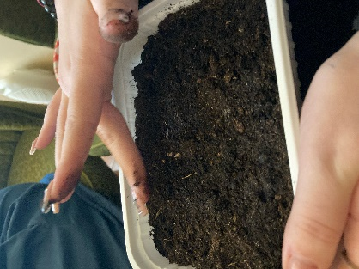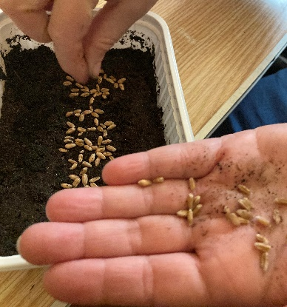

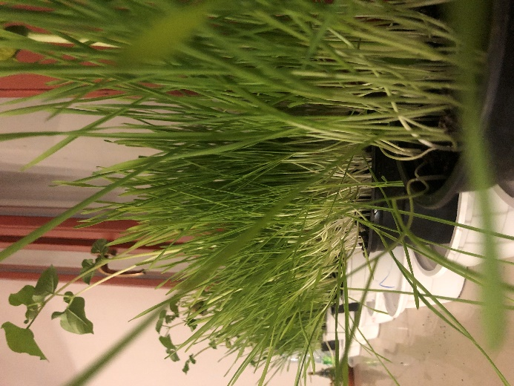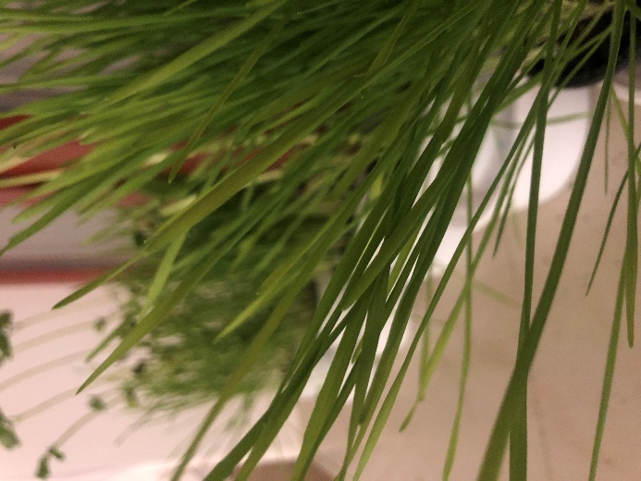

During the months of January and February, we hold our sessions at the Ferenczy Museum, where we work on shaping clay and decorating the finished objects. These sessions get the youngsters in the mood and the tasks of the upcoming project week in Germany next autumn.
