Nature and mental health in schools

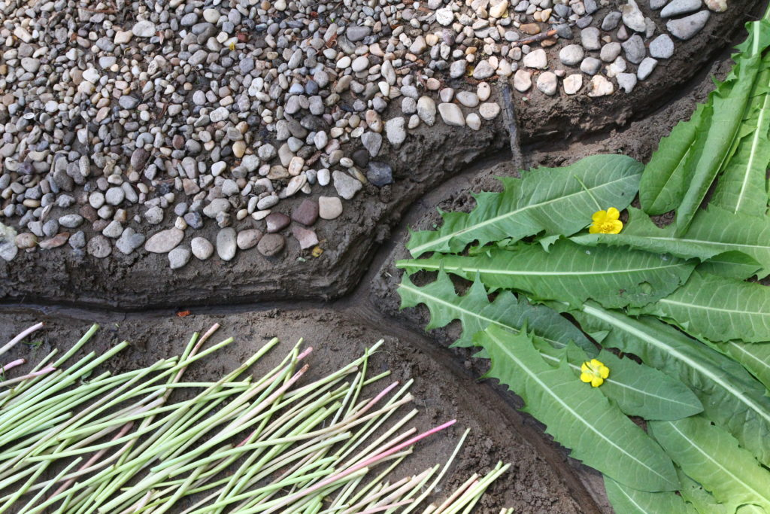

Nature Art Workshop, Szentendre, May 2022

"Although most environmentalists are driven by a passionate delight in the splendour of wild nature, only artists - photographers, filmmakers, landscape painters and poets - appeal to the public with the conviction that human creatures can behave as children of the living planet." (Theodore Roszak)

Nature art is an exciting cross-cutting area of the visual arts where artists emerging from the gallery system (public art, street art) have the opportunity for real, topical, exciting and socially engaged artistic expression in the face of mounting ecological problems.
Nature artists strive to recreate harmony with nature, directly using natural materials, objects, energies and places in their work. Nature is not essentially a subject of representation but rather an attitude.
This attitude is deeply rooted in Eastern cultures, and calls for a kind of mark-making that involves destruction as much as creation, where the work, the magical act, is itself. The natural artist does not create for eternity, he merely works, and even collaborates with nature. The ego is pushed into the background, the artist is not a creator-creator, he is merely a medium. The need for "creative fusion" with nature is clearly manifested in the works of nature art, which is why they are never aggressive, conquering or transformative. Rather, it is an intention to gently "leave a mark" following the inner dynamics of nature.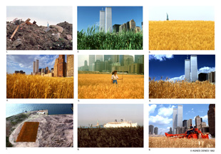 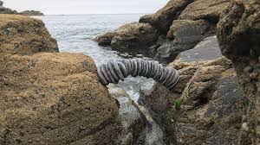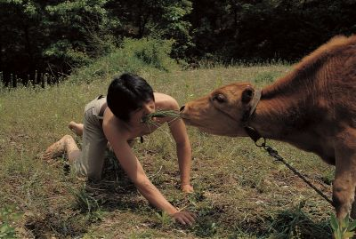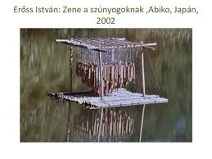

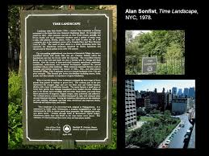

Today's naturalists carry forward both the ethical philosophy of the Far East and the innovative thinking of the North American "eco-naturalists", calling for the ecological paradigm shift they articulate.
The only criterion for voluntary participation in this medium, which has now spread throughout the world and involves a wide range of creative approaches, is an attitude of 'humble approach' to nature.

Károly Elekes, a Hungarian artist of Transylvanian origin, is a "crystal-clear confession of faith in the attitude of nature art":

"Once, I scratched a crack net in fresh mud, and when the dried cracks mostly cut through and through my drawing, which I thought was realistic, I discovered that in some places the line of the drawing and the crack coincided. It was then that I experienced what I could not decipher with brush, needle or photo: I was working with an energy whose laws I had discovered by chance, and it accepted me."

What makes the issue even more significant as an environmental educator is whether the kind of attitude that nature artists have can be taught and passed on, because if so, it could open up a very special platform for environmental education in schools.

Art makes a significant contribution to environmental awareness, as it takes an emotional approach to learning about the environment and building relationships with it.

Particular emphasis was placed on the need to encourage children to develop an emotional connection with nature as a prerequisite for environmental awareness and responsibility. Developing a connection with the environment involves not only knowledge but also emotion. A knowledge-based approach alone cannot influence the deep-rooted values that drive individuals to change their behaviour.

Providing interactive experiences and embracing creative processes that connect children with the natural environment is a key point of environmental education through art. This includes creative approaches to developing problem solving and critical thinking (Wilson, 2013).

Imagination is needed to create narratives about how we can live in a sustainable future.
Art can shape new cognitive patterns, develop a sense of caring, respect and interest in others, improving positive self-esteem and quality of life, and thus contribute to building a sustainable future.
Through art, students can communicate and share their experiences.
Shared experiences are important for the development of identity and ecological sensitivity (York, 2014).

At our international project meeting (9-13 May 2022), we also gave our students a taste of the meditative, restorative, creativity-liberating power of being and creating in a natural environment.

The level of involvement (in terms of time, quantity and quality of the work invested) and the verbal reflections (cathartic experiences) clearly confirmed that it is worthwhile to hold creative activities in a natural environment. The feedback and the photos speak for themselves:
-wonderful, hope, masterpiece, beautiful, stunning, natural, calming, "like praying", hard work, adventure, difficult, teamwork, "learned a lot", very different, unique, interesting, collaborative, creative

I am convinced that the best way to reconnect with Nature, which is also a key concept in ecopsychology, is through sensitive experience, with a lot of time and energy.

Joanna Macy, a deep ecologist and environmental guide, suggests: learn, raise awareness; act, mitigate destruction; and in doing so, create a world around us that we love to live in. As a practising school psychologist, my opinion and experience is that nature art, as a sensitive and accessible means of self-expression, can be particularly suitable for this purpose, since anyone who approaches the natural environment with gentle humility as a partner in existence is sure to protect, to fear, to defend it...

Bibliography:

- ERŐSS, ISTVÁN: A természetművészet különböző megközelítési módjai Keleten és Nyugaton, Doktori értekezés, Pécsi Tudományegyetem Művészeti Kar Képzőművészeti Doktori Iskola, 2008.
- The role of art in environmental education (Vasileios Papavasileiou1*, Eleni Nikolaou, Nikos Andreadakis, Yota Xanthacou, Maria Kaila)in: Proceedings of ADVED 2020- 6th International Conference on Advances in Education 5-6 October 2020
- Students’ Empathy for the Environment through Eco-Art Place-Based Education, (Asvina Sunassee 1,*, Chandradeo Bokhoree and Andrew Patrizio, in: Ecologies 2021, 2, 214–247. )
- Tér-Természet-Művészet https://issuu.com/farkaskonmbe/docs/termeszetmuveszet_oktatas_magyarorszagon

