Nature art - reconnecting with nature

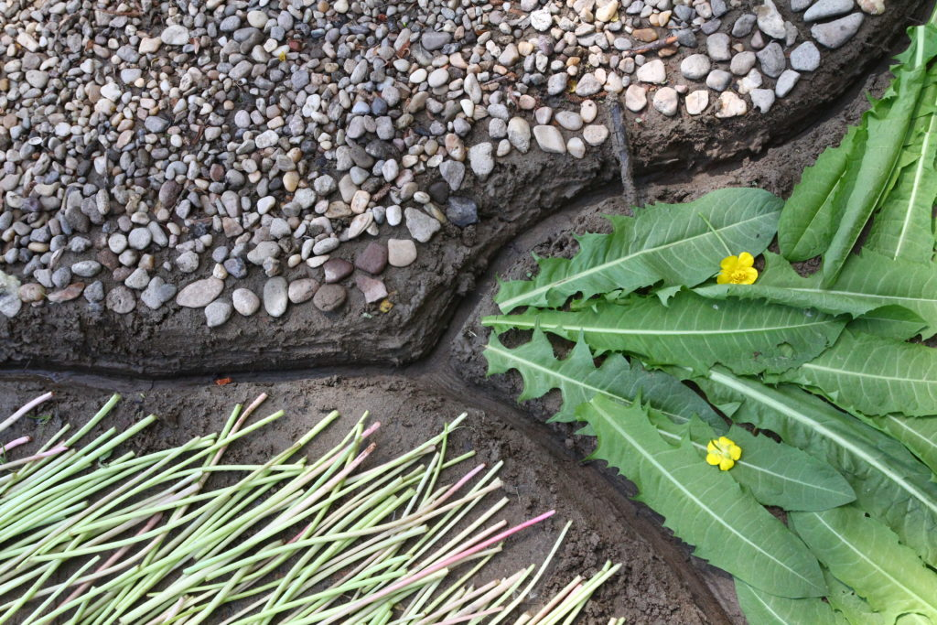
"Although most environmentalists are driven by a passionate delight in the splendour of wild nature, only artists - photographers, filmmakers, landscape painters and poets - appeal to the public with the conviction that human creatures can behave as children of the living planet." (Theodore Roszak)
What makes the issue even more significant as an environmental educator is whether the kind of attitude that nature artists have can be taught and passed on, because if so, it could open up a very special platform for environmental education in schools.
Together, my personal and professional interests have inspired me to learn more about the nature of nature art and its intersection with art. I would like to present a short summary of this.
Nature art is an exciting cross-cutting area of the visual arts where artists emerging from the gallery system (public art, street art) have the opportunity for real, topical, exciting and socially engaged artistic expression in the face of mounting ecological problems.
Today's naturalists carry forward both the ethical philosophy of the Far East and the innovative thinking of the North American "eco-naturalists", calling for the ecological paradigm shift they articulate.
The only criterion for voluntary participation in this medium, which has now spread throughout the world and involves a wide range of creative approaches, is an attitude of 'humble approach' to nature.
Nature artists strive to recreate harmony with nature, directly using natural materials, objects, energies and places in their work. Nature is not essentially a subject of representation but rather an attitude.
This attitude is deeply rooted in Eastern cultures, and calls for a kind of mark-making that involves destruction as much as creation, where the work, the magical act, is itself. The natural artist does not create for eternity, he merely works, and even collaborates with nature. The ego is pushed into the background, the artist is not a creator-creator, he is merely a medium. The need for "creative fusion" with nature is clearly manifested in the works of nature art, which is why they are never aggressive, conquering or transformative. Rather, it is an intention to gently "leave a mark" following the inner dynamics of nature.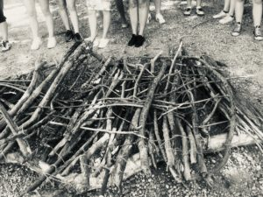
Joint creation from scrap wood - DEC project | photo by Andrea Nánási
Nature art as a genre in the Hungarian art space is linked to István Erőss, who as a creator and teacher was a key figure in the introduction of the artistic attitude from the Far East to Hungary. He is currently the rector of the Hungarian University of Fine Arts, but continues to work as a creative artist.
Károly Elekes, a Hungarian artist of Transylvanian origin, is a "crystal-clear confession of faith in the attitude of nature art":
"On one occasion, I scratched a crack net in fresh mud, and when the dried cracks mostly cut through and through my supposedly realistic drawing, I discovered that in some places the drawing and the crack lines coincided. It was then that I experienced what I could not decipher with brush, needle or photo: I was working with an energy whose laws I had discovered by chance, and it accepted me."
At my workplace, we place a strong emphasis on introducing young people to the intercultural opportunities offered by Erasmus+ international programmes. Our students regularly travel to different European countries for study and professional training. We ourselves, the SzC Petzelt József Technikum and Vocational School in Vác, often host various international events and projects.
One of these is the large-scale DEC (Disciplines in European Context) project, which will run for 3 years (2022-2024) and bring together 6 different countries in Europe (Poland, Lithuania, Hungary, Norway, Sweden, Portugal), where participants will learn innovative methods of inclusive education from each other, in different locations and across different disciplines.
We, in Hungary, chose art as a framework and methodological base.Between 09-13 May 2022 in Szentendre, we hosted 26 participants (15 high school students and 11 accompanying teachers) and worked with them for 5 days in indoor, "studio" and outdoor "outdoor" locations and tools.
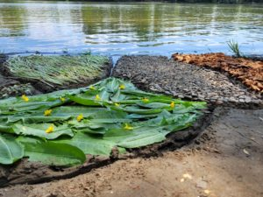
Nature Art on the Danube - DEC project, photo by Júlia Egervári
Water was the motto, the muse of the artworks, and we chose it as the focus of our project tasks, as water is the cradle of life and the arts. The presence of water is also a symbol of geographical cohesion, of "Europeanness". The works created during the week of creation convey a message beyond human creativity: that the preservation of water and its symbolism is our ongoing and eternal task.
With our guests, in addition to studio sessions, we explored/explored outdoor locations, the Danube bank as a creative space and created works of nature art. To give them a taste of the meditative, restorative, creativity-liberating power of being and creating in a natural environment.
As the approach is quite novel, both the young people and their teachers initially approached the task with a timid, hesitant attitude. We can consider ourselves lucky, because on our first day we had the help of nature artist Júlia Egervári, a student of István Erőss, an artist and lecturer at the Eszterházy Károly Catholic University in Eger, who taught and inspired our group with her workshop for the following days.
The level of involvement (in terms of time-quantity and quality of work invested) and the verbal reflections (cathartic experiences) clearly confirmed that it is worthwhile to hold creative activities in a natural environment. The feedback and the photos speak for themselves:

"...wonderful, hope, masterpiece, beautiful, stunning, natural, comforting, "like praying", hard work, adventure, difficult, teamwork, "learned a lot", very different, unique, interesting, collaborative, creative..."
I am convinced that the best way to reconnect with Nature, which is also a key concept in ecopsychology, is through sensitive experience, with a lot of time and energy. Even in a school setting, as educators, we can aim to

"Our simplistic perception, in which we see only isolated objects or living beings, is replaced by a broader and deeper perception, to see the complexity, the unity, the interconnectedness of the world and to recognize the broader temporal and spatial connections. To see our connection to the web of life."
(Zselyke Molnos, Ecopsychology Basics 2016/2020)
Joanna Macy, deep ecologist and environmental guide, suggests: learn, raise awareness; act, mitigate; and create a world around us that we love to live in.
As a practising school psychologist, my opinion and experience is that nature art, as a sensitive and accessible means of self-expression, can be particularly suitable for this purpose, since anyone who approaches the natural environment with gentle humility as a partner in existence is sure to protect, to fear, to defend it...

Andrea Nánási, counselling psychologist and environmental psychologist

Annex: https://youtube.com/shorts/_f4lGZI9458?feature=share

Bibliography:

- ERŐSS, ISTVÁN: A természetművészet különböző megközelítési módjai Keleten és Nyugaton, Doktori értekezés, Pécsi Tudományegyetem Művészeti Kar Képzőművészeti Doktori Iskola, 2008.
- MOLNOS, ZSELYKE: (2016/2020). Ökopszichológia-alapkönyv. Budapest: Ökopszichológiai Intézet)
- Nguyen Luu Lan Anh: Inglehart –Weizel World Cultural Map (2020) Órai Prezentáció, 2022. május 13. ELTE PPK környezetvédelmi szakpszichológus képzés
- ROSZAK, THEODORE: Ahol Psyché és Gaia találkozik, in: IMAGO folyóirat, Budapest, 2019 8(4): 24. o.

