**2023-1-HU01-KA210-SCH-000154584**

**"Be natural!" - a stimulating experiential education project**

**Bős-Csicsó-Dunaszerdahely, 2024. 04. 08-12.**

Between April 08-12, 2024, we organized and conducted the second workshop and series of sessions of the 023-1-HU01-KA210-SCH-000154584 project "Be Natural!" - empowering experiential education project in the centre of Csicsó. The 5-day mobility programme again brought together the cooperating project partners from Dunaszerdahely and Szentendre, students and their accompanying teachers.

There were 10 students from the Hungarian Language Private Secondary School in Dunaszerdahely with two accompanying teachers, and 9 students and 2 teachers from the VSZC Petzelt József Technical and Vocational School in Szentendre.

In order to follow thought the process of the project, it is worthwhile to recall a little the professional background, the objectives and the events preceding the project.

* - On 5 September 2023, a project meeting was organised in Szentendre with the participation of the management of the Dunaszerdahely partner and the colleagues responsible for the implementation.
* - The 1st Nature Art Project Meeting took place in Szentendre from 02 to 06 October 2023 with the participation of students from Dunaszerdahely and Szentendre and their teachers and trainers
* - Between October 2023 and March 2024, at least monthly sessions in both institutions were held for students participating in the project in the context of nature art.
* - On 25-27.02.2024 in Csicsó, the management of the Dunaszerdahely cooperation partner organised a project meeting with the participation of the staff from Dunaszerdahely and Szentendre.

**General introduction to the project week**

Both the organisational and weather conditions were favourable, so the April project meeting was almost entirely as we planned. Unfortunately, a strong cold front arrived on Wednesday, so we were able to hold part of the day's sessions indoors.

The ars poetica of the project week, and its structure, was partly artistic and partly ecological: to understand and make young people more comfortable with the human-nature connection and to support their sustainability attitude through experiential education.

A varied palette of activities was offered to the young people, trying to pleasantly mix theoretical and activity-oriented tasks and situations, so that both the knowledge transfer and the experiential component would be present.

In the student reports of the project week in Szentendre, the receptiveness and demand for relaxation exercises in mental hygiene was repeatedly expressed. For this reason, we tried to be even more conscious when putting together the professional programme and included mood- and well-being-boosting exercises for each day. A positive, relaxed state of mind is also an excellent starting point for creative activities in the natural world.

Our observations and feedback from young people show that our professional objectives have been met. We were able to work in a good atmosphere and along the planned ideas for the project week.

**Our colleague Andrea Zólya faithfully documented the work processes with her camera.**

**The majority of the ecopsychological exercises used during the project week are taken from Andy Mcgeeny's literature summary below!**

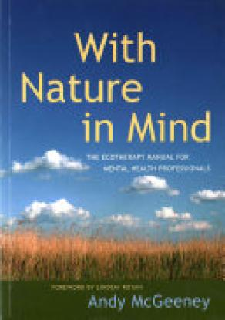

**Detailed presentation of the project week**

Below, we find it useful to report on events on a daily basis, illustrated with photos.

**Project day 1: Monday, 08 April 2024**

We arrived with our students late morning to our project partners in Dunaszerdahely. After visiting the school and having lunch together, we took part in a guided tour of the Csallóköz Museum, where the Director himself gave us an extraordinary presentation of the sights of the region. Prior to the museum visit, the young people involved in the project completed the so-called input measurement, which was repeated on the last day of the project week. The results of the outcome measurement are presented at the end of this report.

After that we continued our journey to Csicsó, where we stayed at the Jolán Pension. The Pension proved to be a very sophisticated and practical place to stay all the time, with three meals a day provided either locally or in the form of a packed lunch. Our students were accommodated in double rooms with private bathrooms. After dinner, we discussed the programme for the days ahead.

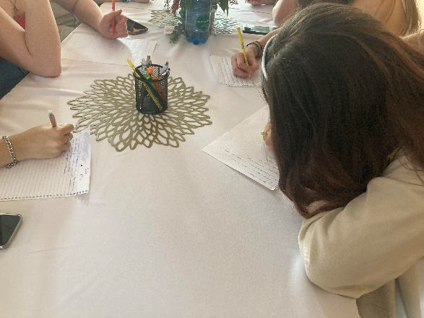

**Project day 2: Tuesday 09 April 2024**

Tuesday was entirely devoted to the study of the floodplain forest around Csicsó and to ecopsychological-artistic practices adapted to the local specificities. Students from Szentendre and Dunaszerdahely and their teachers worked together, individually, in pairs or in small groups. A taste of the exercises:

**Introductory exercise, icebreaker: Indra's net**

1. Interview with nature

2. Frame the picture

3. Gubering list

4. Create a life circle

5. Pile of stones

**Final exercise: an apple becomes part of you**

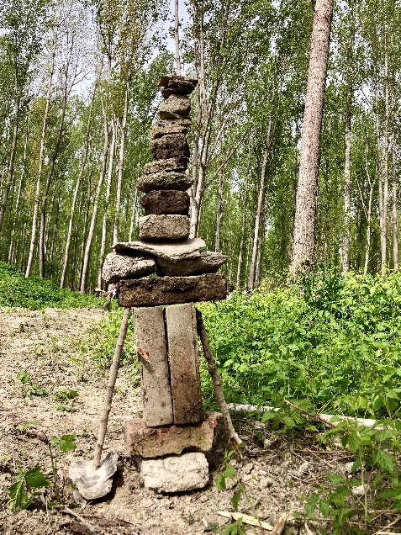 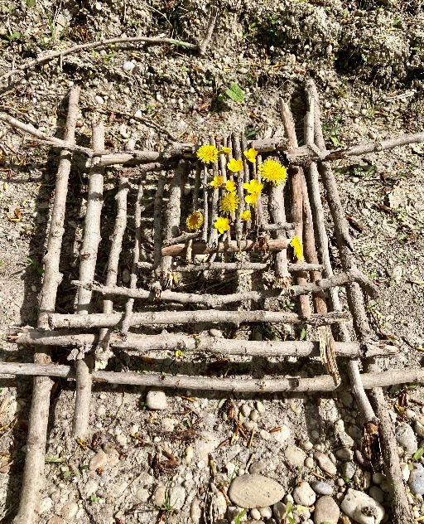

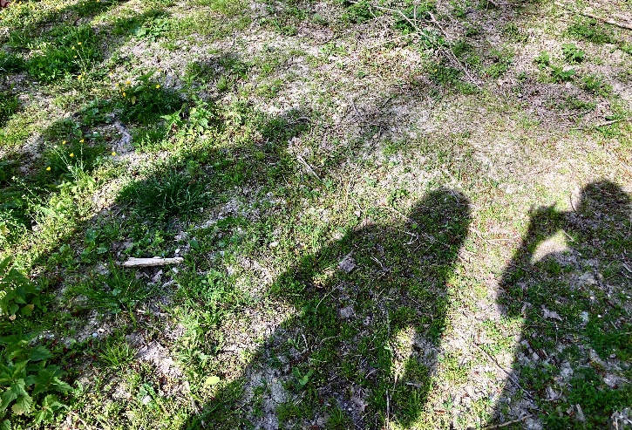

As a leisure activity before dinner, we visited the local animal sanctuary, where the youngsters could "make friends" with both the classic farmyard animals (poultry, donkeys, pigs) and exotic animals (peacocks, llamas).

**Project day 3: Wednesday 10 April 2024:**

This day was divided into morning and afternoon sessions. Leaving Csicsó we settled in the Bős forest and during the morning session we focused on learning about trees and woody habitats and on the implementation of appropriate ecopsychological exercises. In a nutshell:

**Introductory exercise, icebreaker: physical warm-up, general relaxation, limb relaxation**

1. The importance of trees for us

2. Determining the age of a tree

3. Making a forest mobile

Unfortunately, the sudden onset of a significant chill shortened our time outdoors, forcing us to spend an hour warming up in the local cozy pastry shop and comforting ourselves with treats.

Our afternoon programme with textile dyeing artist Rozália Bokros was modified so that we met again in the lobby of the Leisure Centre in Bős after having purchased the necessary plant dyes (green leaves, coloured flowers). Rozi, who is a committed believer in traditional Japanese Far Eastern textile dyeing techniques, taught us a very interesting and relevant technique for our project. By pounding and crushing coloured plant parts thematically placed under silk scarves, a natural dye can be extracted, leaving a trace on the textile. The results speak for themselves.

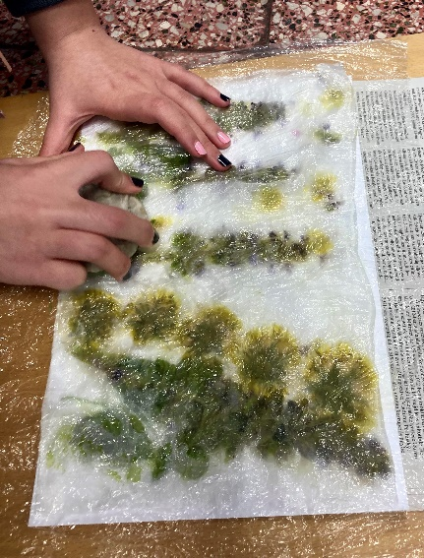 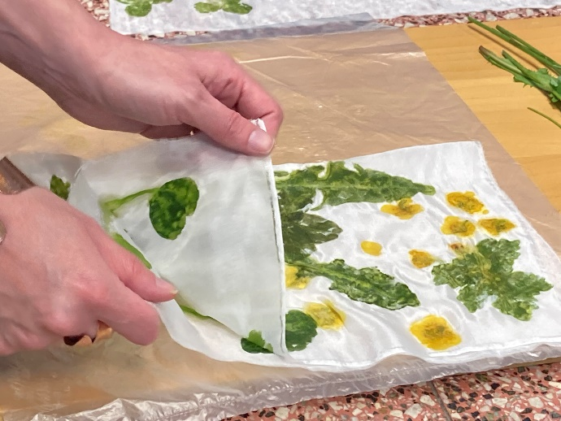

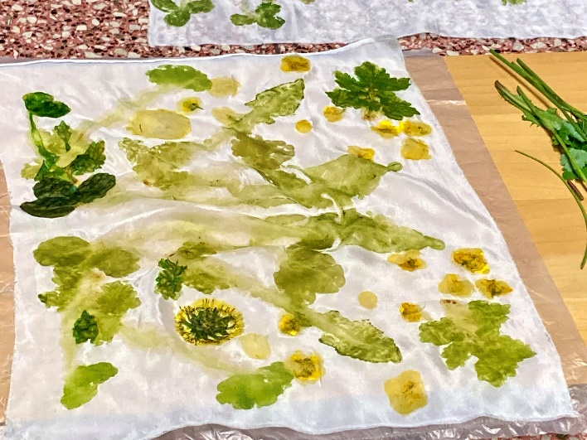

**Project day 4: Thursday 11 April 2024**

For this day, our partners organized a cultural excursion, during which we had the opportunity to visit and get to know the following places and sights:

Komárom, Martos, Gúta (water mill). Fortunately, the weather was kind and there were no problems with the predominantly outdoor activities. Our observations showed that our students were interested and open to the built and natural values of the inter-Callovian landscape.

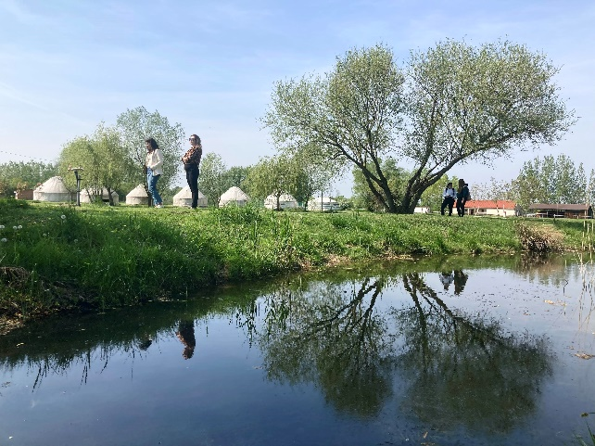 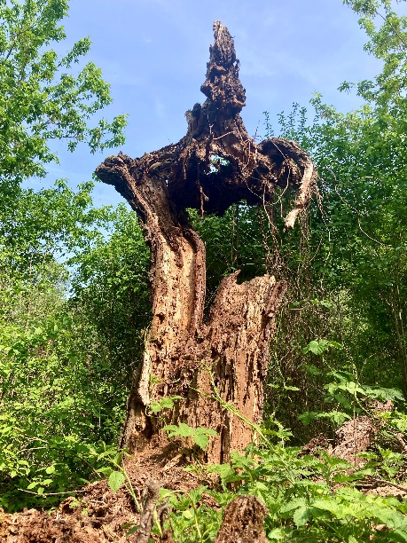

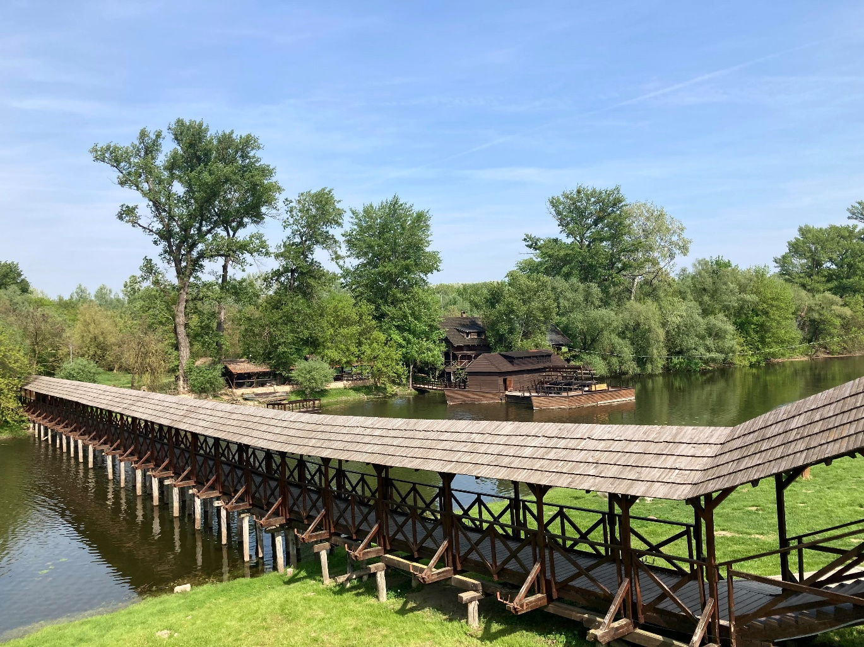

**Project day 5: Friday 12 April 2024**

On our final project day, we had the opportunity to have a morning indoor session, where we tried to cap off the week's events and lay the foundations and fuel for the coming period, for all of us, until we meet again. We watched a 30-minute animated film together (The Man Who Planted Trees (Canadian animated film, 1987) and then shared our reflections.

*...There was once a man who, having done his usual chores, every day picked out a hundred healthy acorns and planted them carefully the next day. Then, years later, trees sprouted in the barren landscape, and people could not understand where they had come from. Then another few years passed, and a veritable wilderness grew up where the seedlings had been. A few more years, and the once barren landscape was filled with life.*

*How much is one man's hard work worth? Can we change our environment or the world? This thirty-minute animated film, based on a story by Jean Giono, is an inspiring example of the power of good will and perseverance, and an encouragement to find the strength and purpose within ourselves to become "tree planters", "everyday heroes"...*

To conclude the morning and the project week (before lunch together), we evoked nature with a popular ecopsychological exercise:

**Downpour**

The sounds produced by the following sequence of movements imitate the formation and passing of a storm.

Ask the group to form a circle. Say: "We'll pretend there's a storm:

"Start by rubbing your hands together, which makes a sound like the wind blowing. The rule is: do what the person to your right is doing - not what I (the group leader) am doing. Unless I am the person standing directly to your right. "

Gradually spread the action around until everyone is doing it. Keep going until you want to move on to the next action. Do the same process for each action.

**The sequence of movements is as follows:**

1. rubbing hands together (the wind is coming).

2. clicking fingers (first raindrops)

3. clapping (heavier rain)

4. slapping thighs (really heavy rain)

5. thumping on the floor and slapping of thighs (rain and thunder).

6. thigh slapping (really heavy rain)

7. clapping (heavier rain)

8. clicking fingers, bouncing (last raindrops)

9. rubbing hands together more and more slowly and quietly (wind stops)

**The organisers' general impressions and reflections on the project week:**

In our experience, it is not difficult to mobilise young people towards activities outside the classroom, in a natural environment. A varied stimulus environment not only provides recreation, but also prepares young people's nervous systems to absorb information that is often shockingly different in a more effective way.

During the project week in Dunaszerdahely, the focus was on eco-psychological-mental-hygiene aspects, with the assistance of sustainability and artistic elements. Our observations and the young people's reports give us the impression that the students participating in the project are increasingly able to tune in and immerse themselves in the recreational and recharging spontaneous learning opportunities offered by the natural environment. In addition, the group of young people from Szentendre and Dunaszerdahely is almost imperceptibly forming an intimate community.

Our primary project objective, that an ecopsychological approach as experiential pedagogy can help create positive change in the personalities of our students, is reassuringly confirmed when we review our measurement results.

**Measurement results**

In this project week, we used a free association approach to measure effectiveness, rather than the previous questionnaires. On the first and last days, students were asked to make free associations to the following questions and prompts. The difference in the content and quality of the resulting so-called word clouds allows us to infer internal processes.

**In terms of sampling, our data are as follows:**

number of items: 19 persons, gender ratio: female: 17 persons male: 2 persons

average age: 16.3 years (youngest participant 15 years, oldest 20 years)

**Call words:**

1. ecological balance

2. human-nature interaction

3. a day outdoors

4. community

5. spring

(extra call word for shot 2: forest)

**Record 1 (08 April 2024)**

**Ecological balance:** balance in nature, consumption, nature, harmony, animals, protection of nature, nature, system, nature, food chain, animals, everything in balance in nature, conservation, wood, unity of nature

**Human-nature interaction**: we affect nature and we have to take care of it, water-environment, everyone looks out for each other, interacting, helping each other out, system, interaction, balance, environment, cars, humans are destroying the Earth, how life works, relationships (family, friendship), cycle, food chain, respect, humans affect the environment,

**A day outdoors**: walking, friends, freedom, grass, green, air, wind, flowers, freedom, relaxation, hiking, sun, Danube, clouds, friends, music, summer, fresh air, nature, beauty, fresh air, hiking, good being, relaxation, cleansing

**Community:** friends, us, friends, friendships, togetherness, friendship, equality, people, many people in one place, people, team, class, attention, understanding, caring, scouts, small company, learning, fun, recreation, friends, friends, friends

**Spring:** flowers, freshness, snow, flowers, blossoming, refreshment, nature revival, flowers, flowers, plants, good weather, flowers, sunshine, birdsong, flowers, renewal, green, blooming, season, cheerfulness, beauty, birthday (:, allergy, flower scent, rebirth

**Record 2 (12 April 2024)**

**Ecological balance:** harmony of animals, people, plants, nature and everything, balance between man and nature, orderliness, consumption, balance in nature, harmony, nature in unity, bees, food chain, environment, peace

**Human-nature interaction:** nature gives (oxygen, food, shelter, humans also give, but rather take away; helping each other out; friendship, love, honesty, honour, loyalty, life, great influence, life, love, care, care, people should protect their environment, be considerate of each other; ecological balance, the cycle of nature; human impact good/bad on the environment; recycling, air pollution¸ environmental protection; take care of nature because we affect it;

**A day outdoors:** peace and quiet; tranquillity; fresh air; hiking, enjoying nature, learning; walking, talking; being in the forest, trees, admiring the landscape; being in nature is good, at least for me it fills me with positive energy; forest, walking, creating, friends; being out in the woods for hours; tranquillity, fresh air; camping, summer; being with friends, walking, playing, relaxing;

**Community:** making new friends and teamwork; knowing how to live together; cooperation, love, inclusiveness, joy, cleverness; togetherness, respect; togetherness, trust, friendship; togetherness, understanding; good to be in community, everyone in their own way; circle of friends, classmates it's a kind of community I think; we (:; a cohesive team; friends, connection; people, school, common ground;

**Spring:** nature reborn; rebirth; beauty, delight, colours, full of life; blossoming, good weather; blossoming, birdsong; allergy, blossoming, glorious colours; rebirth, trees budding, I personally have more energy, I am motivated by the power of the sun, the trees and bushes budding; good weather, my favourite season, nature is beautiful; a season where everything comes alive again; flowers, rebirth, awakening; sunshine, birdsong, renewal, green plants; flowers, fresh air, freedom

**Forest:** life; life, harmony, coexistence; trees, life, living space, creation, fresh air; a fortress in which nature can unfold, the population of trees, the city; trees, walking, water; life-giving, fuel, building material; personally I like being in nature, in the forest, in the park, it fills me up, the air is not as harmful as say in the city. I like to be surrounded by plants and animals; forests and trees are important in life and not just our lives, serenity, freedom; a relatively quiet area to relax; tranquility, fresh air, life; birds, footprints, habitat, trees, air, hiking; home, animals, green canopy; trees, animals, life, tranquility, "another world";

If we look at the associations linked to the call words, the most striking thing is that, in addition to the ecological knowledge increase, there is a significant imprint of belonging, teamwork, learning and various positive, holistic feelings (love, peace, acceptance, renewal, recharging, unity).

Based on this, it is perhaps not an exaggeration to say that ecopsychological-natural-art experiential pedagogical activities are able to induce stimulating processes by activating the inner motives of the personality, which cannot be neglected in the process of knowledge transfer in the field of institutional education.

The significance of the pedagogical-psychological developmental goal of the "self-force", as formulated in the report of the project week in Szentendre, needs to be emphasised here again:

"...a young person with a well-developed sense of self is able to create harmony between himself and the expectations of the community. He has a good sense of reality (he feels safe). He accepts himself. He is productive and takes pleasure in activity. He has good relations with people and nature. Ability to be spontaneous. He has sufficient inner freedom but is socially sensitive."

***The report was prepared by Andrea Nánási, the director of "Be Natural!" professional leader of the experiential education project, environmental psychologist. Photo documentation by Andrea Csilla Zólya.***

***Szentendre, 2024. április 29.***